Allowing Installation from Unknown Sources
Android blocks APK installs by default unless the user allows installs from the source application (Chrome or files).
- Open Settings
- Open Apps (or Security/Privacy)
- Locate Special App Access
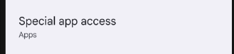
- Select Install Unknown Apps
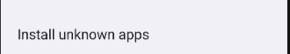
- Select the app used to open the APK (Chrome, Files, Drive, etc.)
- Enable Allow from this source
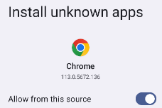

Installing the APK
- Open the APK file
- Review the installation prompt
- Tap Install
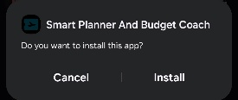
- Wait for Android to complete the installation
- Tap Open to launch immediately or Done to exit.
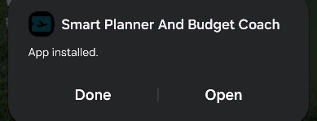

Launching the Application
The user launches the application by tapping the app icon from the home screen or app drawer.
